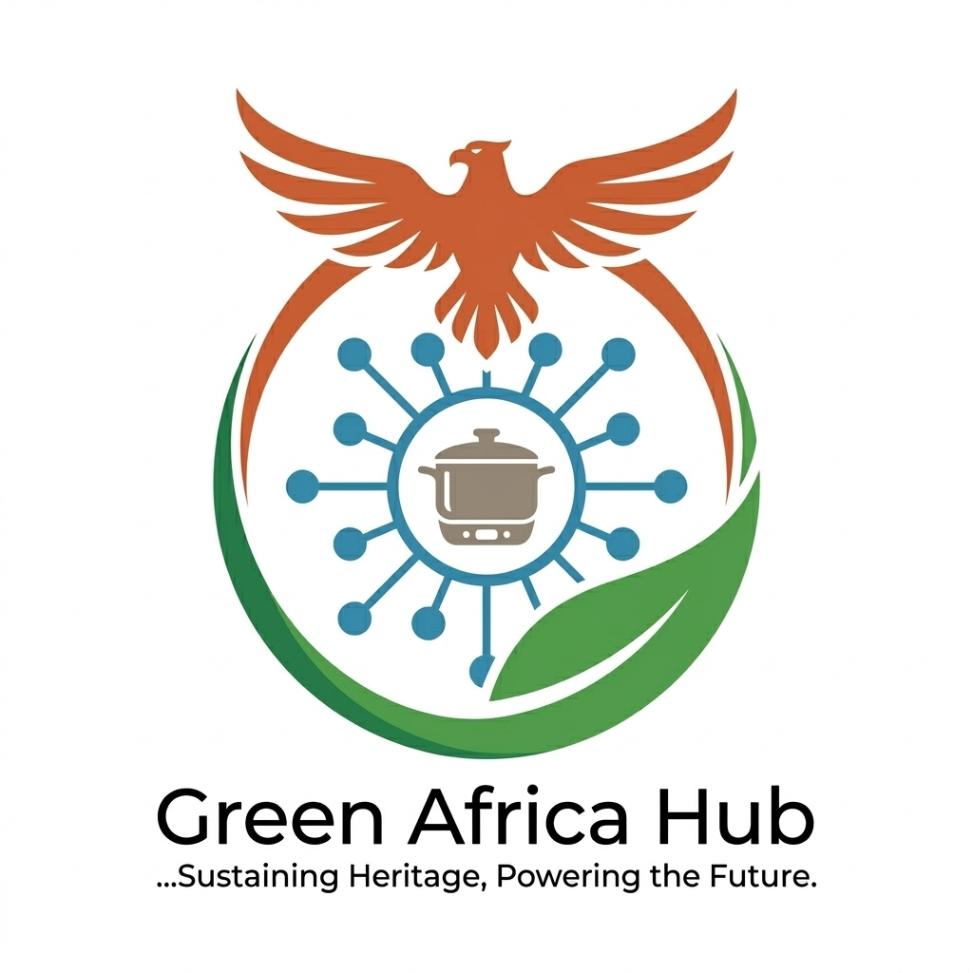 | GREEN AFRICA HUB LTD  Sustaining Heritage, Powering the Future  Company No. 17107299 | www.greenafricahub.org.uk | gracetuase@gmail.com | 07776 643169

Smart Kitchen Hub
Community Pilot Proposal
A Partnership Proposal for [Community Venue Name]
March 2026
1. WHO WE ARE
Green Africa Hub Ltd is a Bristol-based social enterprise incorporated in March 2026 (Company No. 17107299). We are developing the UK’s first Smart Kitchen Hub focused on African and Caribbean communities — combining energy-efficient induction cooking, carbon tracking, and practical sustainability education.
Our founder, Grace Omotuase, is a Chartered Manager (CMgr), holds an MSc in Financial Technology from the University of Bradford, a Data Science Certificate from the University of Texas at Austin, a Professional Cookery qualification from Bradford College, and has 14 years of financial leadership including 12 years at the Central Bank of Nigeria. Grace has spent 18 months developing the proprietary Smart-Prep Methodology™ — a system that adapts traditional African and Caribbean recipes for energy-efficient induction cooking, reducing carbon emissions while preserving authentic cultural flavours.
Green Africa Hub is supported by Future Leap (WECA-funded sustainability accelerator) and is aligned with the West of England Combined Authority’s Net Zero targets.
2. THE PILOT WE ARE PROPOSING
We are seeking a community venue partner in Bristol to host a series of three pilot Smart Kitchen Hub sessions between April and June 2026.
What the sessions involve:
- Duration: 2.5 hours per session
- Participants: 8–15 community members per session (African and Caribbean households, micro-caterers, and interested community members)
- Equipment: We bring our own portable induction hobs and all cooking ingredients
- Format: Hands-on cooking using Smart-Prep recipes, live carbon tracking demonstration, Q&A and community discussion
- Cost to participants: Free or £5 suggested donation (pilot phase)
Session themes:
Session 1: Smart-Prep Basics — Introduction to energy-efficient cooking and carbon savings
Session 2: African Flavours, Green Futures — Adapting traditional recipes for induction cooking
Session 3: Carbon Tracking in Your Kitchen — Using data to reduce your household footprint
3. WHAT WE ARE ASKING FROM YOU
We are looking for a venue partner who can provide:
- Use of a kitchen or community space with electricity access for 3 sessions (approximately 3 hours each including setup and clear-up)
- Basic seating for 8–15 participants
- Promotion of the sessions to your existing community network
In return, Green Africa Hub will:
- Deliver all sessions free of charge to your community members
- Provide all equipment, ingredients, and printed materials
- Share anonymised session data and carbon impact report with your organisation
- Acknowledge your venue as a founding community partner in all future communications and materials
- Cover all costs of the pilot — there is no financial commitment from your organisation
4. WHAT WE WILL MEASURE
The pilot will generate real evidence to demonstrate community demand and programme impact:
Metric | What we will measure
Attendance | Number of participants per session and return rate
Engagement | Participant feedback scores and qualitative comments
Carbon savings | Estimated CO₂ saved per session vs equivalent gas cooking
Energy cost saving | Average energy cost saving per household per meal
Willingness to pay | What participants would pay for ongoing sessions
Community interest | Number of people who express interest in joining as members

This data will be used to refine the programme, inform our funding applications, and demonstrate real community impact to grant funders and investors.
5. TIMELINE
Date | Milestone
April 2026 | Venue partnership confirmed, sessions promoted
May 2026 | Session 1 — Smart-Prep Basics
May 2026 | Session 2 — African Flavours, Green Futures
June 2026 | Session 3 — Carbon Tracking in Your Kitchen
June 2026 | Pilot report produced and shared with venue partner
July 2026 | Findings presented to funders and Future Leap
6. ABOUT THE FOUNDER
Grace Omotuase founded Green Africa Hub after witnessing firsthand the disconnect between mainstream sustainability messaging and African and Caribbean households in the UK. Having built a career spanning financial leadership at the Central Bank of Nigeria, data science, and professional cookery, she brings a rare combination of technical rigour, cultural knowledge, and community credibility to this venture.
“Sustainability is everyone’s business — and should be the business of everyone. Green Africa Hub exists to ensure Black communities are not just part of the green transition, but leading it.”
— Grace Omotuase, Founder & CEO
7. NEXT STEPS
If your organisation would like to explore hosting the Green Africa Hub pilot, we would love to arrange a short introductory call or meeting at your convenience.
Please contact:
Grace Omotuase — Founder & CEO, Green Africa Hub Ltd
Email: gracetuase@gmail.com
Phone: 07776 643169
Website: www.greenafricahub.org.uk

We look forward to hearing from you.

